**Walk 23 Orleton and Bircher**

Last walked in Jan 2016

**Description.**  A 6 km (3¾ miles) easy winter walk, four stiles. 90 per cent country lanes and open common.

**Start.** Orleton village hall. Explorer Map 203. Grid 487674.

**Directions from Whitecross Roundabout** (Turn milometer to zero). Take the A4110 Canon Pyon (Three Elms road) for 1 mile and TR at the traffic lights onto the A4103 to Worcester (Roman road). TL at the first roundabout (2 miles), onto the A49 to Leominster. Go straight across the next two roundabouts (9.5 miles then 12.5 miles) on the A49 heading towards Shrewsbury. TL at the next roundabout (13.3 miles) onto the A44 to Leominster. At 13.8 miles TR onto the B4361 towards Richards Castle. Go thru Luston and at 18 miles you TR at the T-junction for Ludlow. At 19 miles you TR for Orleton Village. A little further on (L) is the village hall.

**1.** **Orleton Village Hall.** Leave the hall car park and TR, walk on for 75m to reach the B4361. Go straight across the cross-roads (Baker’s Arms pub is on the L) and walk on up Green Lane, a narrow road that’s going towards Orleton Rise. Go past some houses and continue on to pass Rose Cottage (L) and then Broad Green Farm (R) to reach a road junction where you TL, the Caravan Park is on your R hand side. Gently climb this narrow lane, passing Barn Hall (L). At the next junction the road bends L, (ignore the No Through Road ahead).

**2. “Holly” Lane.** Go past Rise Hill cottage (L) and some intermediate holly trees. Descend for 500m, go round L bend to reach the next T-junction. TR and go up a No Through Road, after 200m you go thru a wooden gate. Walk on another 75m and look for a narrow footpath on your L.

**3. Bircher Coppice.**  TL and climb up thru the trees, swinging around to the L as you continue quite stiffly up to the stony edge of the coppice. Emerge and keep ahead on the (now) grassy track thru the bracken, with a cottage and barn down to the L. The track widens to an aggregate drive (to the cottage), dropping L and R, passing a small parking area and leveling to a high marker post.

**4. Farm drive.** Turn sharp L down the farm drive to a shorter marker post, which is to the L of Woodend Farm. From the marker post you continue in the same direction and descend the dingle, ford trickle of a stream and pass Lower Woodend Cottage (R) to continue in the same direction and over a stile into a field {F1}. Continue along the R field edge, over a stile that’s next to a cottage and into {F2}, continue along R field edge. Cross over another stile into {F3} and head straight for the house (with three windows) and stile in front. Cross over the stile and TR, walk down a drive. Go past Pennyfarthing Cottage (R) to reach a lane.

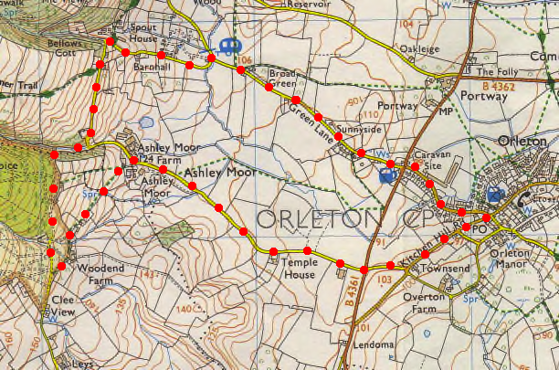**5. Lane.** TR and go down the lane for just over a kilometer, passing Asley Moor Hall and Temple House, to reach the B4361 cross roads. Go straight across and up the narrow lane opposite that’s between high banks, to reach the next T-junction.

**2**

**3**

**6. Kitchen Hill Road.** TL, walk on past Little Furlongs, (L, no through road) to reach Orelton Post Office. TL down Millbrook Way, to get back to the village hall.

**5**

**1**

**6**

**4**